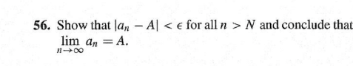

|  |  |  |  |
| --- | --- | --- | --- |
| **Proof based question** | | | |
| Question Code: | Sample 6 | Solution ID: | Sample solution |
| Answer: | * In previous question ‘55’   It has been shown that for sequence there exist a number , and for a small integer  such that  , for all   * From we can also write        * Hence, from  it has showed that**.** * As equation holds, then by the definition of convergence of sequence, it is said that   be a convergent sequence with being it’s limit.   * Which means, as gets up to infinity we get a number   that concludes: | | |
| Step-by-step 1 | | | |
| Description: | * In previous question ‘55’   It has been shown that for sequence there exist a number , and for a small integer  such that | | |
| Calculation: | , for all | | |
| Step-by-step 2 | | | |
| Description: | Now in  if then it also must satisfy | | |
| Calculation: |  | | |
| Step-by-step 3 | | | |
| Conclusion: | * Hence, from  it has showed that**.** * As equation holds, then by the definition of convergence of sequence, it is said that   be a convergent sequence with being it’s limit.   * Which means, as gets up to infinity we get a number   **That concludes**: | | |